* **Creating First XML Document  
    
  - Create a new file named books.xml**

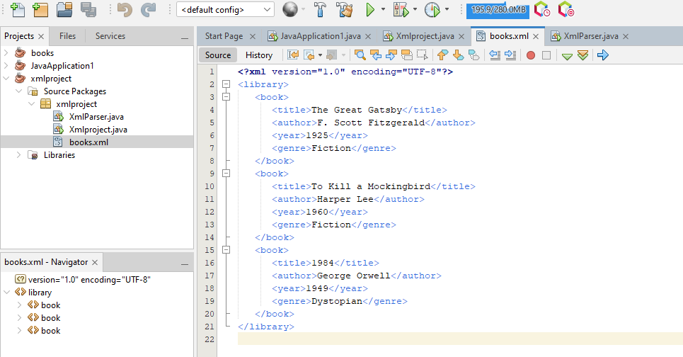

* **Parsing XML in Java**
* **Create a Java Class for XML Parsing:**

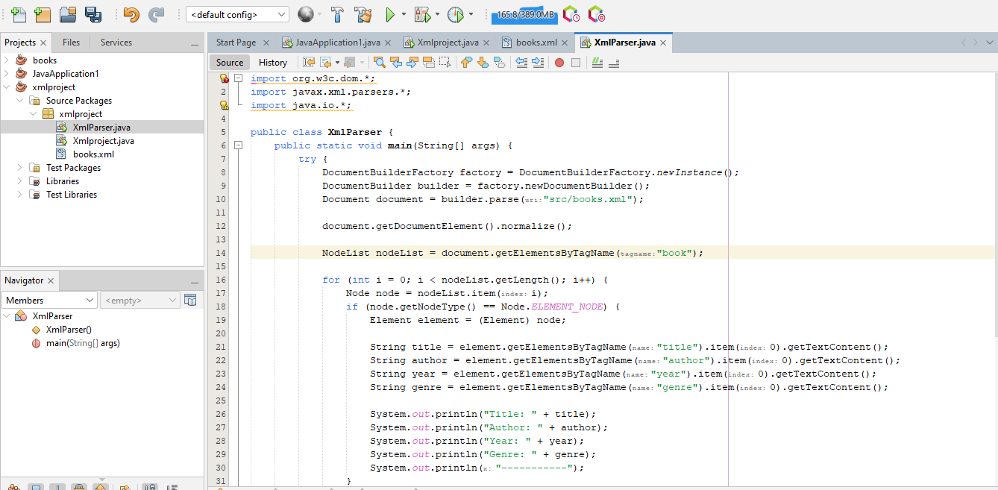

**Output**

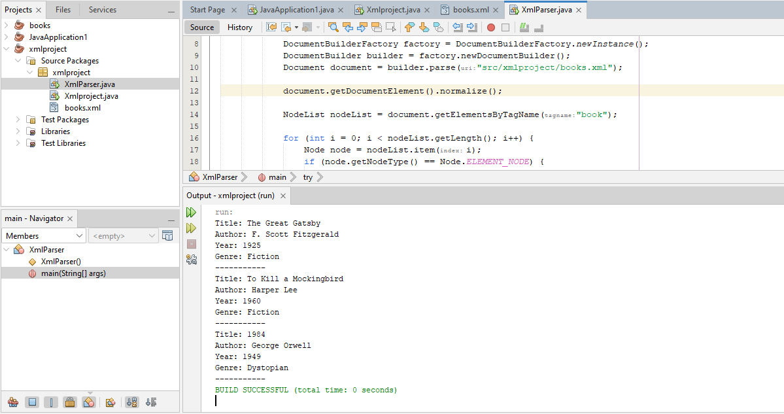

**Modifying XML Data**

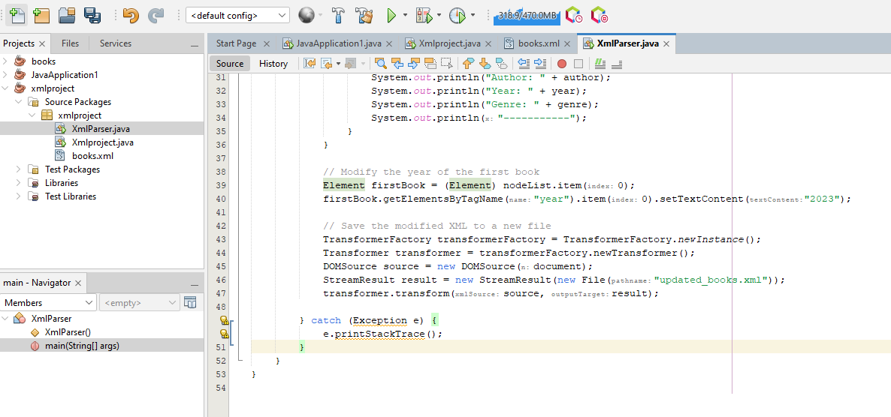

**Output**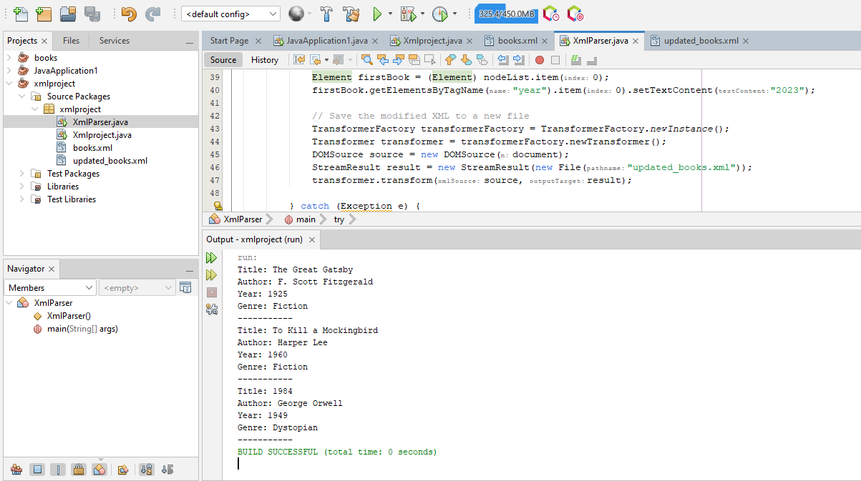

**updated_books.xml**

